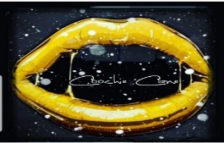
COOCHIE CANE SALE PRICE LIST
PINEAPPLE COLLECTION $55 COMES WITH 1 PINEAPPLE SUGAR SCRUB, 1 PINEAPPLE MASSAGE OIL AND 1 PINEAPPLE LIP BALM
BH COLLECTION $55 COMES WITH 1 BROWN SUGAR AND HONEY SCRUB, 1 PINEAPPLE YONI SPRAY, 1 CHERRY LIP SCRUB AND 1 PINEAPPLE LIP BALM
BUNDLE $65 COMES WITH 1 SUGAR SCRUB, 1 PINEAPPLE MASSAGE OIL, 1 CHERRY LIP SCRUB AND 1 PINEAPPLE LIP BALM
8 OUNCE SUGAR SCRUB WITH 300MG OF CBD $30
2 OUNCE BOTTLE OF PINEAPPLE MASSAGE BODY OIL WITH 100MG OF CBD $25
CHERRY LIP SCRUB WITH 75MG OF CBD $10
PINEAPPLE LIP BALM WITH 75MG OF CBD $12
PINEAPPLE YONI SPRAY $10
*ALL SALES FINAL*
*SOME OF OUR PRODUCTS CONTAIL ALMOND OIL AND COCONUT OIL IF YOU HAVE A NUT ALLERGY*
*7% SALES TAX WILL BE ADDED TO ALL ORDERS*

